Photo: emeagwali.com
Philip Emeagwali
Photo: emeagwali.com
DESCRIPTION
DATE

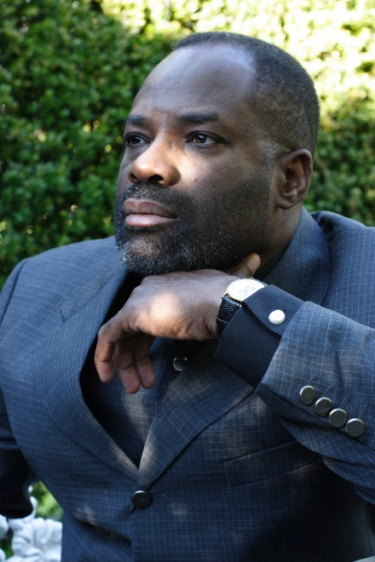
Philip Emeagwali
Photo: emeagwali.com
Pho
Philip Emeagwali
Photo: emeagwali.com

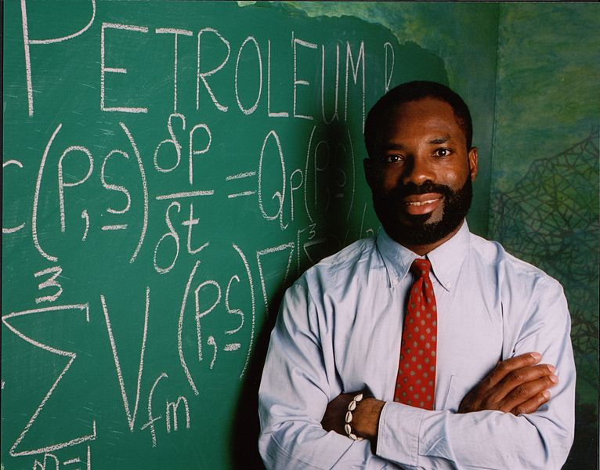
Photo: emeagwali.com
https://upload.wikimedia.org/wikipedia/commons/1/1f/Philip_Emeagwali_with_scribbled_Exxon-Mobil_equations.jpg
